

Great Falls Conservation and Access Proposal

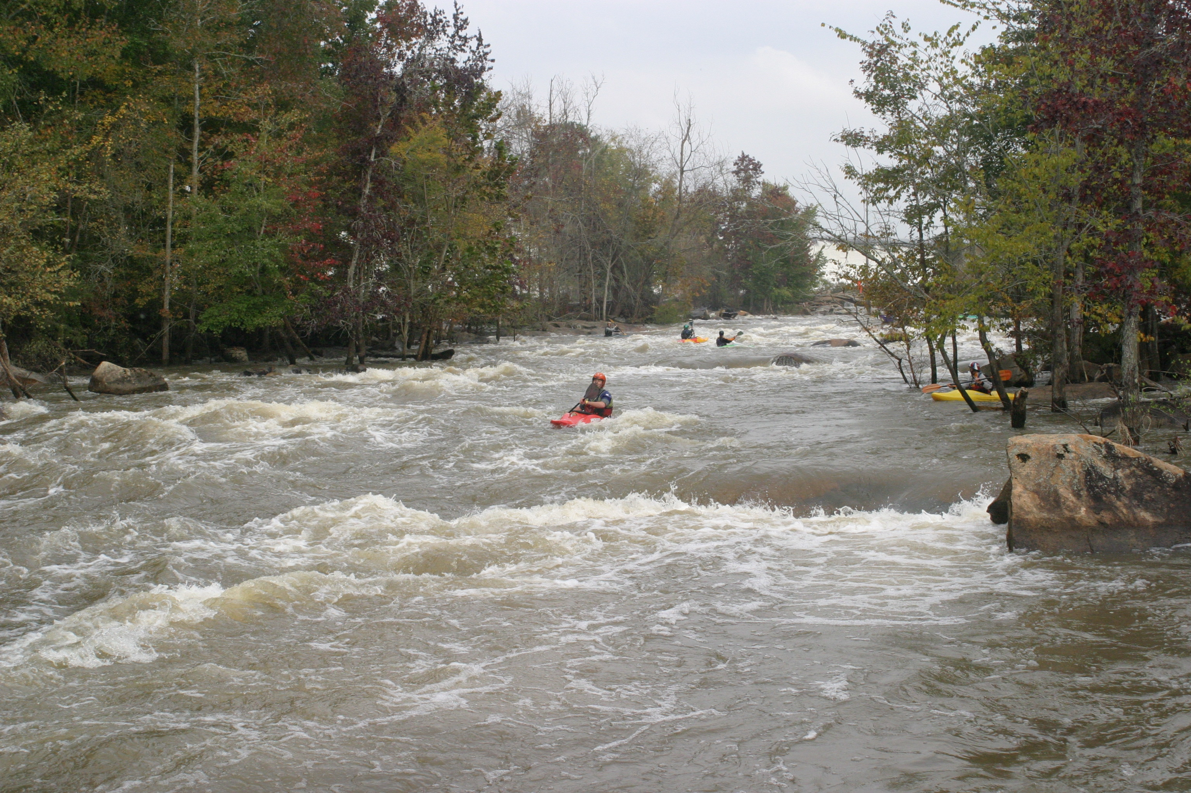

by American Whitewater

Submitted March 3rd, 2005

- Introduction

American Whitewater’s mission is to protect and restore our nation’s whitewater rivers while enhancing opportunities to enjoy them safely. We represent roughly 6,500 members and 80,000 affiliate members who are primarily non-commercial whitewater boaters. We have been involved in over 100 dam relicensings across the country and this proposal is based on that wealth of experience. We feel that our proposal meets many diverse interests, protects and restores ecological functions to the Catawba River Ecosystem, and provides new recreational opportunities in a responsible manner. We view this proposal not as a comprehensive proposal, but rather as detailed proposal for public recreation in the Great Falls area. It is our hope that this proposal will gain support and be integrated into basin-wide proposals. American Whitewater has significant interests in other river reaches and the basin as a whole that include land conservation, public recreation, and water quality that are not addressed in this proposal.

Specifically, in this proposal American Whitewater requests that:

- The islands of Great Falls be protected by some means, and that Duke assists with the infrastructure of a new Great Falls State Park should the formation of a state park be adopted as the preferred means of protection.
- Riparian areas along Fishing Creek and Camp Creek be protected and restored where possible.
- Specific river access areas and trails be constructed and maintained.
- Hiking and biking trails be collaboratively considered.
- A limited number of trees be removed from the Great Falls river channels.
- A flow delivery channel or series of channels be built at the Long Channel weir in order to provide two way fish passage, base flow delivery, boat passage, whitewater play boating opportunities, and a falls sound.
- Spills be managed to increase recreational and ecological benefits.
- Flow information be improved
- Recreational flows be adaptively managed to ensure efficiency and predicted high quality boating experiences.
- A continuous, variable, robust, scientifically determined base flow be restored to both channels of the Great Falls.
- Recreational releases be provided on both channels of the Great Falls.

- Basis for Proposal

2.1. FERC Regulations supporting river access

Our request for public access enhancements to the Catawba River is based on a strong legislative base that itself is built on the Public Trust Doctrine and federal navigability laws. Section 2.9 of the Federal Power Act has several standard conditions that clearly state that it is the duty of the Licensee to provide recreational access.

Article 18 states:

“So far as is consistent with proper operation of the project, the Licensee shall allow the public free access, to a reasonable extent, to project waters and adjacent project lands owned by the Licensee for the purpose of full public utilization of such lands and waters for navigation and for outdoor recreation purposes, including fishing and hunting: Provided, That the Licensee may reserve from public access, such portions of the project waters, adjacent lands, and project facilities as may be necessary for the protection of life, health, and property.” (emphasis in original)

Article 17 states:

“The Licensee shall construct, maintain and operate or shall arrange for the construction, maintenance and operation of such reasonable recreational facilities including modification thereto, such as access roads, wharves, launching ramps, beaches, picnic and camping areas, sanitary facilities and utilities, and shall comply with such reasonable modifications of the project structures and operations as may be prescribed hereafter by the Commission during the term of this license upon its own motion or upon the recommendation of the Secretary of the Interior or other interested Federal and State agencies, after notice and opportunity for hearing.”

2.2. Ecological Benefits of flow restoration

Bypass reaches like the Great Falls have some very serious ecological problems that are often a restoration focus during dam relicensings. The ecological impacts associated with bypass reaches are as follows:

- The ecology of bypass reaches can best be described as “Hell or High Water.” The reaches typically flow at very low flows as provided by leakage, groundwater discharge, tributary inflow, or a mandatory minimal release from the dam – and they also infrequently flow at very high flows that result from the dams having to spill water due to unusually high inflow.
- Low flow conditions eliminate the quantity and quality of the aquatic habitat available for aquatic species – turning river into rock.
- Water quality and temperature are often impacted by low flow conditions as the water is far more shallow and stagnant than normal.
- Riparian vegetation encroaches into the river channel as the ecosystem seeks to establish a smaller redefined stream channel bordered by terrestrial habitat.
- Very high flows periodically scour vegetation, aquatic organisms, and sediment from the channel and essentially reset the ecosystem.
- Disturbance adapted species, often exotic, are artificially selected to live in the channel while many species that have not evolved mechanisms to deal with radically low and high flows may disappear from the channel.
- In cases where the flow has been greatly reduced such as the great falls, the aquatic habitat and species composition may more closely resemble a chain of small pools and wetlands than a river.

The concept behind the restoration of dewatered bypass reaches is summed up well on many dehydrated food packages – “just add water!” The restoration of a constant base flow provides water for aquatic animals to live in, improves the quality and temperature of that water, can increase native biodiversity, supports fish migrations, naturally removes inappropriate terrestrial habitats, and reduces stranding effects after large spills. The restoration of flow events higher than base flows maintains healthy riparian areas, redistributes sediment, naturally scours aquatic vegetation as well as encroaching riparian vegetation, and maintains channel shape and structure. Natural rivers flow at a constantly changing range of flows creating a mosaic of habitats and habitat conditions. Both are essential parts of regulated river restoration.

2.3. Recreational Benefits

The Great Falls of the Catawba currently provide almost no recreational opportunities. Dewatering, lack of access, and inadequate flow information combine to virtually eliminate paddling opportunities. Lack of access further reduces public enjoyment of the area by hikers, mountain bikers, and anglers. The Great Falls is in many ways a forgotten treasure. The combination of large tracts of forested lands with existing unmanaged trails, close proximity to large population centers, high quality whitewater boating opportunities, beautiful scenery, noteworthy biodiversity, mild climate, interesting history, and location relative to other whitewater opportunities all combine to make the Great Falls a very desirable location to travel to for whitewater boating as well as hiking and mountain biking. Our proposal seeks to bring this recreational potential to fruition.

The Great Falls, once restored, will be the closest whitewater river to hundreds of paddlers, if not thousands. Paddlers from Colombia and Charlotte and the areas in between will regularly use the Great Falls as will paddlers from all points south and east. Paddlers from the mountains will be attracted to the Great Falls because of its warm climate, interesting scenery, and summer boating opportunities. Our proposal seeks to provide a range of opportunities to attract paddlers. Specifically, paddlers will be able to:

- Paddle the Class II Long Channel during scheduled releases of optimal flows
- Park-and-play on high quality features associated with the base flow channel(s) in the Long Channel every day of the year.
- Paddle the Class III Short Channel during scheduled releases of optimal flows
- Park-and-play on the high quality natural play waves in the Short Channel during releases and spills.
- Paddle both channels during unplanned managed spills at a wide range of flows
- Potentially paddle both channels at suboptimal base flows for part or all of the year.

This range of opportunities will benefit many different types of paddlers and will attract paddlers to the Great Falls every day of the year.

Our proposal also benefits other user groups, and indeed many paddlers and their families also like to mountain bike and hike. Our proposal will restore the sights and sounds of the Great Falls by restoring a range of flows, and will provide access to the Falls for hikers through trail building and mapping. The islands trail system that we propose will offer miles of hiking opportunities for tourists and local citizens alike. Hiking and bird watching are very popular activities and will likely flourish in this very unique area.

2.4. Economic Benefits

Whitewater paddlers contribute a significant amount of money to local economies surrounding the rivers that they paddle. Through spending money on gas, food, lodging and other items paddlers provide revenue to rural communities. This side effect of whitewater recreation is typically welcomed in these communities and comes at a very low cost, since the towns do not need to market rivers..

The Great Falls of the Catawba have the potential to once again become a tourist destination – and one that provides some significant economic benefits to the Town of Great Falls and the surrounding region. The river itself has the potential to attract a consistent number of whitewater play boaters to features available every day of the year, large numbers of whitewater paddlers on days when the reaches are releasing or spilling, and consistent numbers of non-whitewater paddlers and hikers that are attracted to the reservoirs, trails, and sights of the Great Falls.

Several studies have measured or predicted the economic impacts of whitewater recreation on local and regional economies. We have collected these studies and have summarized the findings, as well as provided direct links to these studies whenever possible. It is difficult to predict the amount of use that the Great Falls will attract but we feel confident that there is a significant demand for the opportunities that Great Falls could provide. When considered in concert with enhanced land based recreation, it is evident that the restoration of recreational and ecological values of the Great Falls will have a measurable economic benefit on the surrounding region. The following references show these effects on other rivers.

Studies of Economic Effects

In 2002 Charles Sims, a graduate student at the University of Tennessee, wrote an excellent summary of several peer reviewed journal articles focused on the economic impact of whitewater paddling. This article is highly recommended as a starting point for anyone interested in the topic. The findings of his summary are described in Table 5.4.1.

Table 5.4.1. Economic Data as Summarized by Charles Simms, 2002.
River | # of People | Total Economic Output ($) | Total Income ($) | Value Added ($) | Jobs | Year of Data
Upper Delaware | 232,000 | 13,351,000 | 5,582,800 | 6.222,200 | 291.93 | 1986
Delaware Water Gap | 135,400 | 6,929,000 | 3,246,300 | 3,695,200 | 156.37 | 1986
New River Gorge | 100,000 | 2,567,600 | 1,217,700 | 1,391,200 | 57.93 | 1986
Upper Klamath | 3,000-5,000 | 490,500-817,400 | 245,300-408,900 | - | 16-26 | 1988
Chattooga | 39,000 | 4,350,000 | 2,470,000 | 2,750,000 | 97.07 | 1992
Gauley | 45,000 | 8,490,000 | 4,680,000 | 5,310,000 | 208.17 | 1992
Kennebec | 36,000 | 10,650,000 | 5,980,000 | 6,650,000 | 271.32 | 1992
Middle Fork Salmon | 4,500 | 9,700,000 | 5,160,000 | 5,830,000 | 237.70 | 1992
Nantahala | 213,000 | 14,370,000 | 8,120,000 | 9,040,000 | 334.62 | 1992

A more recent study than those listed in Table 5.4.1 once again estimated the economic impacts of boating on the Gauley and New rivers, as well as the Cheat River. The findings of this study, Whisman et al, 1996, are summarized in Table 5.4.2.

Table 5.4.2. Economic Statewide Impacts of Boating Use as Estimated by Whisman et al, 1996.
River | # of People | Total Economic Output ($) | Total Income ($) | Value Added ($) | Jobs | Year of Data
Gauley | 232,000 | 23,095,000 | 8,996,000 | - | 556.7 | 1995
New | 135,400 | 33,924,000 | 13,019,000 | - | 805.4 | 1995
Cheat | 100,000 | 2,251,000 | 868,000 | - | 53.5 | 1995

A recent in-depth study was carried out by NC State University (sponsored by and American Rivers and the US Park Service) found that in 2001 roughly 43,000 people visited the Chattooga River. Even in this low visitation drought year, the authors of the study found that boaters annually spent 1.8 million dollars in a 6 county area, resulting in a total economic benefit of roughly 2.7 million dollars. The full Chattooga Study is available online and is an excellent resource.

Predictive Economic Studies

In addition to these studies of actual spending patterns, several robust predictive studies have been carried out on regulated rivers prior to the restoration of flow. A 1997 US-Forest Service environmental impact statement regarding the Upper Ocoee River in Tennessee predicted that recreational releases would generate roughly $210,000 per day. American Whitewater and our partners were successful in 2004 in securing 54 annual releases on the Upper Ocoee which should result in an annual economic benefit of roughly $11,340,000. A similar Study carried out by the Licensee on the Cheoah River in western North Carolina predicted that each release would generate roughly $155,000 per day. While the actual number of recreational releases has yet to be determined, Table 5.4.3 shows the economic impact of a range of release numbers. Table 5.4.3 is based on the assumptions from the relicensing economic and recreation studies, specifically that an average day of releases would draw 576 commercial boaters spending $234.38 each, and 256 private boaters spending $79.84 each.

Table 5.4.3. Predicted Economic Impacts of Recreational Releases on the Cheoah River.
Number of In-season Whitewater Days | Total Annual New Output in Graham County | Economic Output as % of Annual County Retail Sales | New Employment (includes Guides)
0 | $0 | 0.0% | 0.0
1 | $155,440 | 0.4% | 5.1
2 | $310,879 | 0.8% | 10.2
5 | $777,199 | 2.0% | 25.4
10 | $1,554,397 | 3.9% | 50.9
15 | $2,331,596 | 5.9% | 76.3
20 | $3,108,795 | 7.8% | 101.8
30 | $4,663,200 | 11.7% | 153.0
40 | $6,217,590 | 15.6% | 203.5

Whitewater Park Studies

Whitewater parks are increasingly being built in towns across the country. While use of these parks is consistent and the towns are generally pleased with the aesthetic and health benefits of the parks, few studies have reported the economic impact of the parks. One example is the recent Golden Whitewater Park Study, focused on the Clear Creek Whitewater Park in Golden Colorado, which reported positive results. The authors found that the annual value of the Whitewater Park (based on boater spending) is between 1.4 and 2.0 million dollars per year. The authors also estimated significant future increases in that value.

Additional Resources

For further information on the economic benefits of river stewardship we encourage those interested to view two annotated bibliographies. The first is a document published by the National Parks Service’s Rivers, Trails, and Conservation Assistance Program titled The Economic Benefits of Conserved Rivers: An Annotated Bibliography. The second such resource is another Annotated Bibliography that was generated by American Whitewater. This document focuses on economic research methodology, recreation, and hydroelectric projects. A related resource for learning about whitewater boating use levels and trends is the Outdoor Industry Association, who publish an Annual Participation Study addressing many forms of outdoor recreation.

3). Great Falls Conservation and Access

3.1. Land Conservation, Water Quality and the State Park Concept

American Whitewater strongly believes that the islands associated with the Great Falls of the Catawba are highly deserving of protection because of their unique and high quality ecological, recreational, and cultural values. Duke’s proposal to allow the state of SC to turn the islands into a new State Park meets these interests, and there are other potential solutions as well. We strongly support the idea of Great Falls becoming a State Park for a variety of reasons. Specifically, we feel that protecting the islands from development will have significant ecological benefits, that recreational enhancements will create exciting new boating, hiking, and biking opportunities for regional and local residents alike, and that increased visitation could yield economic benefits for the Great Falls Area.

In support of these ideas, we have outlined specific river access and hiking trails in this proposal that we feel would best serve the paddling, hiking, and biking public. We feel that Duke Power should construct these trails in advance of the creation of the new Park, in consultation with SC State Parks and other stakeholders.

We recognize that the infrastructure required to support a new state park is significant, and we support integrating relicensing mitigation with planning for a new State Park through shared design and construction efforts, cost sharing, and volunteer efforts. We hope that the future proposals by other stakeholders can better identify additional infrastructure needs and opportunities.

In addition to enhancements made to the Great Falls and their immediate surroundings, we look forward to negotiating environmental mitigation elsewhere that can benefit the Great Falls area. Rivers are continuums – even dammed rivers – and are therefore directly affected by management upstream, downstream, and in tributaries. American Whitewater feels that a primary river conservation tool at the relicensing team’s disposal is riparian area protection, restoration, and management. We hope that this relicensing process can produce a means of improving water quality and habitat (both aquatic and terrestrial) through promoting riparian area conservation.

Within the Great Falls area there are two significant tributaries that could potentially be enhanced to improve the water quality and available habitat for aquatic and terrestrial species; Camp Creek and Fishing Creek. Once connected through land protection and fishway structures at the weir(s), these two creeks and the Great Falls themselves will be able to foster significant ecological recovery. American Whitewater therefore recommends that efforts be initiated to protect and restore the riparian areas of these two tributaries. As a placeholder we recommend that Duke Power set aside $30,000 for each of these two streams, to be used to educate and offer incentives to private landowners willing to protect or restore their land along these creeks. It is likely that this money may best be used to work with the NRCS and the counties through a collaborative effort. A more detailed plan for protecting these creeks should be worked out collaboratively with stakeholders.

3.2. Trail Descriptions (refer to map)

American Whitewater is recommending the construction of several new trails and the enhancement or opening of several existing trails. The trails that we are recommending are designed to make use of existing roads and trails as much as possible, minimize any ecological impacts, and to provide high quality hiking, biking, and boating opportunities. We feel that the blue river access areas and trails on the map below are essential to adequately supporting recreational boating through a new license for the Catawba Project. We feel that the red hiking trails, or more likely some collaboratively designed version of the red trails, should be constructed in advance of the creation of a new State Park to facilitate public use and enjoyment of the project area. We ask that other stakeholders consider the blue trails and the red trails as two separate proposals.
At each major access area and trailhead we request a kiosk be constructed that is capable of displaying educational materials, regulations, and maps. Duke power should also collaboratively design trail maps and make them available to the public.
Most of the red trails are actually existing old or functional roads that merely need to be opened to the public and in some cases cleared of deadfall or brush. On the Map and in the following description of the trails, LC refers to the Long Channel of the Great Falls, and SC refers to the Short Channel.

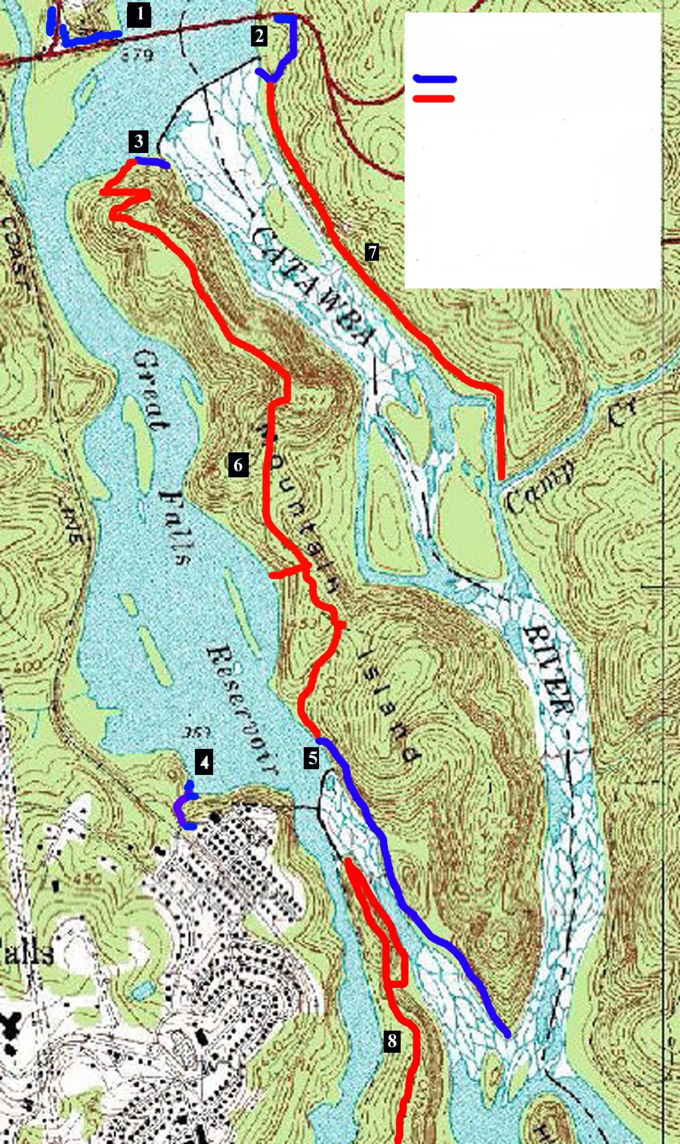
Proposed River Access Areas and Trails

River Access Trail
Hiking Trail

1. LC Put In Access Area
2. LC Alternate Put In Access Area
3. LC Weir Portage Trail
4. Great Falls SC Access Area
5. SC Weir Portage and Riparian Trail
6. Mountain Island Trail
7. LC Riparian Trail
8. Dearborn Island Trail
9. Adventure Connector Trail
9

1. LC Put In Access Area

This access area will serve as the primary access area for paddlers wishing to paddle the Long Channel and also primary access point for flat water boaters wishing to hike on Mountain Island. Paddlers will park in an area or areas TBD between the Duke Offices used during the flow study and the west side of the bridge spanning the Catawba immediately downstream of Fishing Creek Dam, and then carry their boats to the reservoir. Parking should be enhanced at the bridge itself, and in the immediate vicinity. In addition, the current rough trail down to the reservoir from the bridge should be improved (widened, hardened, steps added). Garbage facilities should be maintained at this site, and portable toilets may be needed.

2. LC Alternate Put In Access Area

A river access area on the east side of the bridge spanning the Catawba immediately downstream of Fishing Creek Dam will provide alternate river access, angling access and hiking access to the LC Riparian Trail, and possibly to Mountain Island via the Adventure Connector Trail.

3. LC Weir Portage Trail

This new trail is needed to allow paddlers to portage around the LC Weir and enter the LC itself for either downstream paddling or play-boating near the weir. The trail will follow a similar path as used during the flow study and will be only 100 to 200 feet long.

4. Great Falls SC Access Area

The primary paddling access for the SC will be from the Town of Great Falls. This will encourage paddlers to visit the Town, and will also provide the most convenient access to the upper end of the SC. Currently the access area that was used during the flow study is gated and rough. The gate should be opened, and the parking lot should be cleaned up, graveled, and if at all possible made larger. Garbage facilities should be provided at this area, and it should be managed as a day use area. An informational kiosk should be erected at this access area, in cooperation with American Whitewater and SC State Parks.

5. SC Weir Portage and Riparian Trail

The SC Weir Portage Trail is an essential element of this proposal, and will allow paddlers to access the upstream end of the SC by portaging around the SC Weir and putting in immediately downstream. During the flow study, boaters used ropes to lower boats down to the river and to hold on to while walking to the river. A structured (ie wooden steps) trail is needed to allow paddlers to carry their boats down to the gently sloping bedrock that leads to the river.

The actual trail to the Put In will be a spur trail off of the longer SC Riparian Trail which will parallel the SC for its entire length. The Riparian Trail will meet various objectives:

- Flatwater paddlers traveling down the Catawba could use it to portage the weir, whitewater rapids, and/or dewatered SC.
- Whitewater paddlers could hike back up this trail with their boats after running the SC, and take out at the same place they put in (Great Falls SC Access Area).
- Whitewater paddlers could use this trail to carry back up for multiple runs and playboating descents of the first rapid on the SC. Many paddlers will want to paddle this rapid many times, in order to surf every wave many times. This rapid has strong potential to become a destination play-boating opportunity.
- Whitewater paddlers that paddle the LC, would have the option of hiking up the SC on the Riparian Trail, and either paddling the SC or paddling back to the top of the LC on the canal/reservoir.
- Hikers that have any type of boat could access the LC Riparian Trail from Stumpy Pond or Great Falls and hike the trail in order to view the rapids or go fishing.

The SC Riparian Trail would be a new trail requiring construction.

6. Mountain Island Trail

The Mountain Island Trail is not a boating access trail, but rather a hiking trail. The trail would follow existing overgrown roads for at least 70% of its length and the remainder would follow fairly low gradient contours. This trail, in combination with the SC Riparian Trail would allow hikers to see the entire length of Mountain Island ranging from the rapids of the SC to the highest point of Mountain Island. This is beautiful country. Hikers would access the trail by boat from the LC Access Area, the Great Falls SC Access Area, or stumpy pond. It is also possible that hiking access could be provided from the LC Riparian Trail and the Adventure Connector Trail.

7. LC Riparian Trail

The LC Riparian Trail already exists as a gated gravel road that parallels the LC. We are simply requesting that hiking be formally allowed on this road and that it be tied in with the LC Alternate Access Area. This trail would allow hiking access to the Great Falls area for those with no boat, and could possibly provide a connection to Mountain Island.

8. Dearborn Island Trail

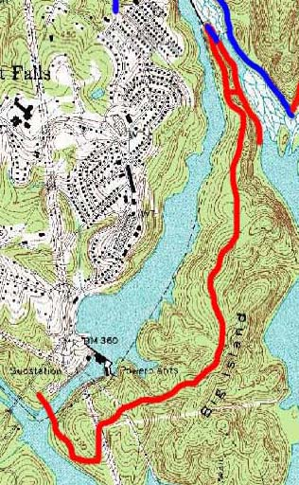
At least 90% of The Dearborn Island Trail already exists as a long dirt road that travels the length of the Island, and that is currently able to be driven on. We request that Duke develop a plan to allow hiking and biking access to the island via this trail. This trail will provide a new and major open-space resource for the Town of Great Falls. It is likely that hiking and particularly biking this trail could become a significant destination activity that would draw people to the Great Falls area. Potential impacts may have to be analyzed prior to allowing hiking or biking in areas of known archeological significance.
Dearborn Island Trail

9. Adventure Connector Trail

In our many trips into the Great Falls area, we several times crossed the LC from the mouth of Camp Creek to Mountain Island. It is possible that a “trail” could be developed that would allow hikers to replicate this adventure, even with enhanced base flows in the LC. The trail would cross mostly on islands and would likely require wading across areas of still water. It may be possible to build relatively flood resistant single-log bridges to make this a dry crossing. Regardless, any trip across the LC is an adventure that would take hikers through a diverse jungle of upland, riparian, wetland, and stream habitats. This trail would be the only dry-land means of accessing the Mountain Island Trail System. This trail could be a very unique regional attraction if designed creatively, and would have a vast interpretive/educational potential.
Dearborn Island Trail

3.3. Tree Removal:

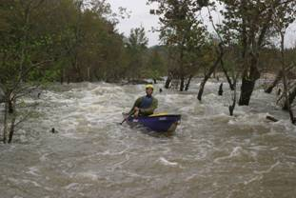
Healthy rivers, especially whitewater rivers, do not typically have trees growing below the high water mark. However, vegetative encroachment is a very common occurrence in bypassed reaches like the Great Falls. The Great Falls currently hosts a strange and unnatural ecosystem that suffers from a combination of no water conditions and high water conditions. The result is a river choked with upland and riparian vegetation that is capable of enduring occasional high water conditions. As base flows are restored to the channels though, many of these trees and shrubs will die and be replaced with appropriate aquatic habitat.

Trees growing in the river obviously pose an unnatural threat and inconvenience to paddlers. The Great Falls, while relatively filled with trees, still offers recreationally passable river channels. However, the selective removal of less than 100 small to medium sized live trees, as well as some shrubs from the Great Falls will make paddling a safer and more enjoyable experience – suitable to a wider range of boating abilities. Through increasing safety, tree removal will allow more individuals of varying abilities to enjoy the Great Falls. Tree removal will also improve visibility of the Great Falls, and may allow paddlers to access the LC from river left. Tree removal may also need to occur in association with base flow provision structures in the LC. Selective tree removal can be designed based on aerial photography, and collaboration with AW.
The goal of tree removals will be to provide high quality and reasonably safe paddling experiences in the Great Falls. Trees will only be removed that obstruct desired routes of travel or pose an excessive risk to paddlers’ safety. By removing trees, and in association with improved flows and access, the Great Falls will offer a series of exciting and beautiful blueways.

3.4. Multipurpose Base Flow Delivery System:

American Whitewater requests that one or more structures be retrofitted onto the LC weir that can deliver a continuous base flow into the LC. Such structures will be used to pass the agreed upon base flows, provide 2-way fish passage, provide an appealing “falls sound”, add oxygen to the water, provide downstream boating passage, and provide one or more high quality whitewater play features. A very high quality play feature could be designed to function at a range of flows and provide a desirable destination boating opportunity nearly 365 days per year. Examples of similar structures can be researched at http://www.wwparks.com/ and at http://www.amrivers.org/doc_repository/AFS_Paper.pdf. In addition, American Whitewater has created some very rough conceptual artwork of what these structures might look like.

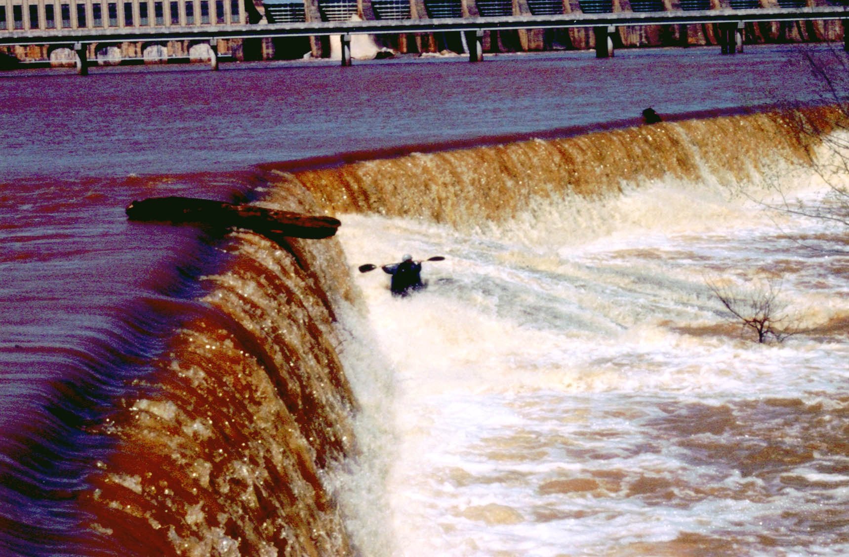
The LC Weir as it is now
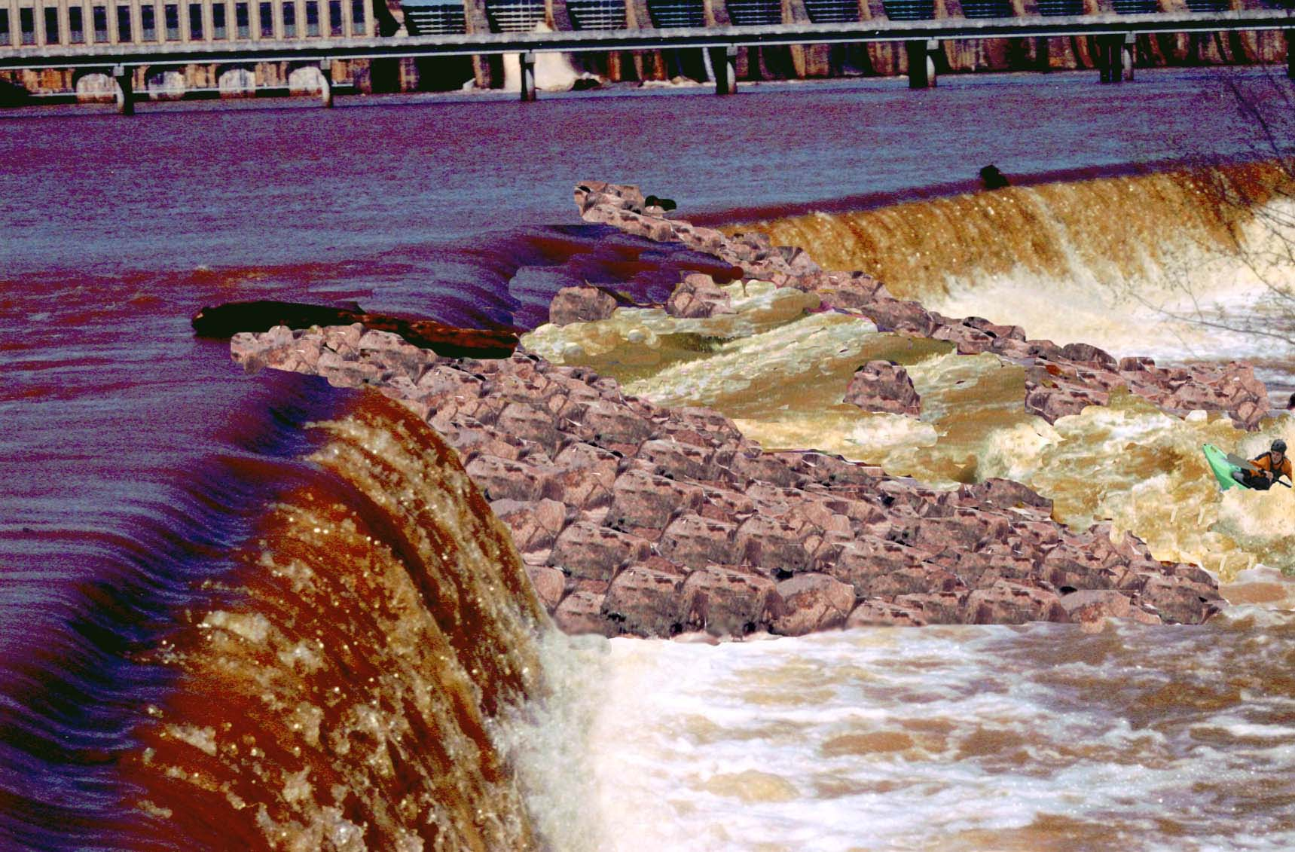
Basic conceptual design, note that the weir would not normally be spilling.
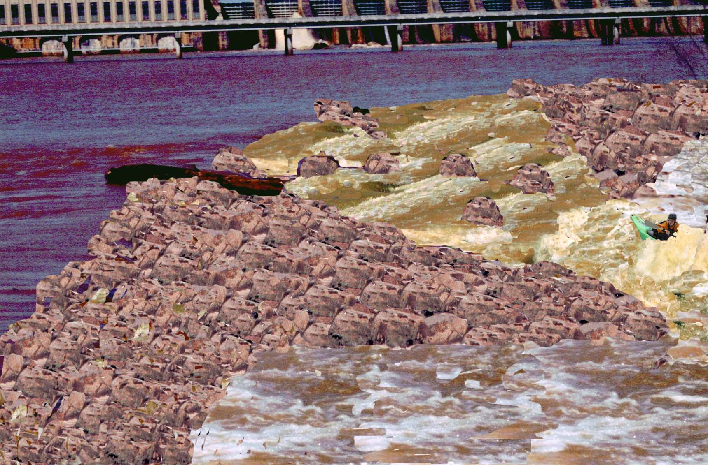
Conceptual design with wider intake area, with the weir not spilling, and natural rock added to the weir for appearance.

3.5 Flow Regime Proposal

The following flow regime proposal in an integrated ecological and recreational flow regime proposal that addressed spill management, adaptive management, base flows, and higher than base flows in both the Long Channel and the Short Channel.

3.5.1. Spill Management:

Natural spills stochastically provide variable flows in both Great Falls Channels that could provide recreational and ecological values, if they are managed for those values. Managing spills comes at little cost to Duke Power yet will provide the public with recreational opportunities.

The graph below depicts the average number of days per month that Fishing Creek Dam spilled at any flow. Fishing Creek Dam spilled an average of 16.47 days per year, however only 5-6 of those days each year are within a flow range suitable for boating. These statistics are based on spill records from 1970 to 2003. We assume that spill at Fishing Creek is equivalent to spill into the Great Falls.

Currently, spills are managed with only one objective: moving water through the river system in times of high inflow. This will always be the primary purpose of unplanned spills – regardless of other secondary management objectives. The current management of spills yields little recreational value and is known to strand fish such as gar, resulting in mortality of these individuals. Enhanced spill management could enhance the public’s ability to see the Great Falls running at historic levels, support paddling use of spills, and decrease ecological impacts of spills. Uncontrolled spills provide unique opportunities for paddlers to enjoy a wide range of flows in the Great Falls.

American Whitewater therefore requests the following measures be added to Duke Power’s spill management at the Fishing Creek Dam.

- Spills should be ramped down after spill events in a manner that does not reduce the flows by more than 10% in any one hour or 30% in any 24 hour period. No ramping protocols are recommended for increasing flows. It is very possible that more specific and justified ramping protocols can be developed using the in-stream flow study data. These ramping protocols will reduce fish stranding, and will provide the paddling community with some degree of certainty regarding flows associated with spills.
- Duke Power should develop a spill notification system that notifies the public of spill occurrence and volume via a website, email service, and phone service. This service should be updated by 9am each morning on which a spill is predicted.
- An online USGS gage is needed in the LC to assist with the monitoring of spills and base flows by Duke, the public, resource agencies, and the FERC. We request such a gage be installed.

3.5.2. Adaptive Management:

Little is known about the specific recreational flow preferences for use of both channels. The flow study gave us a general feeling for various flows, but the complexities involved with flow delivery casts a shadow of doubt on the replicability of flow conditions. Furthermore, there may be subtle changes in flow that can change play features from nonexistent to spectacular. The relatively few number of flows experienced during the study were instructive, but ultimately inadequate to fine tune flow recommendations. We therefore recommend that the stakeholder group work to develop an adaptive management plan for flow restoration to the Great Falls that can adaptively enhance recreational opportunities to meet demand, while preventing Duke from incurring additional costs.

3.5.3. Base Flows:

American Whitewater strongly supports the restoration of continuous, variable and robust base flows to both the Short Channel and the Long Channel of the Great Falls. Such flows are critical to accomplishing ecological river restoration. We are not yet aware of the specific habitat provided by different flows in the Great Falls so are unable to recommend a specific base flow. In general we would like to see a variable base flow that changes following historic seasonal patterns.

3.5.4. Recreational Releases

To complement the base flow and ecological restoration objectives, we recommend a recreational release pattern that roughly follows the natural flow patterns. The hypothetical regulated hydrograph below shows how recreational releases can be added to a base flow regime in a manner that will restore some functions – if not the structure - of the historical flow regime. If natural spills were to be added to the visual depiction of the hydrograph then a truly complete picture could be seen. The result is a hypothetical flow regime that provides aquatic habitat, channel restoration, diverse whitewater boating opportunities, and the aesthetic benefits of the sights and sounds of Great Falls.

For comparison, the natural hydrograph of one year of the Catawba River can be viewed below. A pattern is evident that base flows are higher in the winter and spring than in the summer and fall. It is also evident that stochastic events of increased flow occurred throughout the year. While we have described these releases as “recreational releases” it should be noted that such flows have significant ecological benefits.
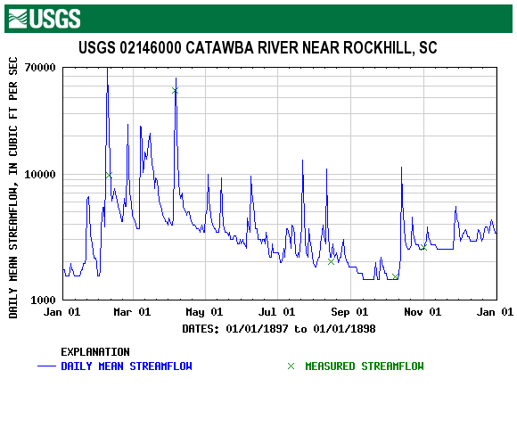

The recreational releases that we have requested in both channels total 5800cfs. These flows are highly consistent with small to moderate rain driven flow events associated with both the natural and regulated hydrograph for the Catawba River. Specifically, for the period of record, the Catawba River at Rock Hill flowed at over 5800cfs for an average of 92 days per year, and was between 3800 and 10,800cfs for an average of 152 days per year. Recreational releases are also much lower than the annual peak flows in the Catawba River. The graph inserted below offers a comparison between the requested recreational releases and the flows for the Catawba River. The recreational releases should not be considered disturbance flows or even high flows, since they are similar to or slightly higher than the mean river flow, and are vastly lower than natural or regulated peak flows.

3.5.5. Long Channel Recreational Releases.

The Long Channel has excellent natural whitewater opportunities that we seek to restore to a limited extent through this proposal. We feel that recreational releases in the long channel, combined with the appropriate access, could attract significant use by whitewater boaters. The estimated optimal flow for paddling the Long Channel is 2,940cfs.

We request that Duke Power provide recreational releases in the LC on two Saturdays out of every month, from 10 am until 6 pm, at a flow of 2,940 cfs +/- 300cfs (exact flow to be determined based on adaptive management), from March 1st through October 31st. In addition, we request that 4 Sundays be provided to create 4 full weekends of boating opportunities. This represents a total of 20 days of scheduled recreational opportunities on the Long Channel. We request that ramping protocols for recreational releases be collaboratively developed and implemented. Additionally, we propose that the timing of flow events change from year to year to provide additional variability to the restored hydrograph.

3.5.6. Short Channel Recreational Releases

The Short Channel has exceptional natural whitewater playboating opportunities that we seek to restore to a limited extent through this proposal. We feel that recreational releases in the short channel, combined with the appropriate access, could attract significant use by whitewater boaters. The estimated optimal flow for the Long Channel is 2,860cfs.
Recreational releases can be made in the Short Channel by either spilling over both the Short Channel and Long Channel weirs simultaneously, or can be made by lowering the flashboards in the Short Channel to provide higher flows in the Short Channel only. In order to allow different flow management in each channel we
recommend that pneumatic flashboards be installed on the Short Channel Weir. Examples of these flashboards can be seen at http://www.obermeyerhydro.com/index.htm). Based on other similar projects, American Whitewater roughly estimates that Duke Power could have 4-foot tall pneumatic flashboards installed on a 100 foot long section of the Short Channel weir for about $140,000. These flashboards would be capable of providing 2,720cfs into the short channel, which is roughly the preferred flow for paddling the Short Channel. The pneumatic flashboards could also handle ramping and could be used to deliver a constant base flow of any lesser amount to the Short Channel.
We therefore request that Duke Power provide recreational releases in the Short Channel on two weekends out of every month, from 10 am until 6 pm on Saturday and Sunday, at a flow of 2,860 cfs +/- 300cfs (exact flow to be determined based on adaptive management), from May 1st through October 31st. In addition, we have requested that Duke provide releases in the Long Channel on two Saturdays in March and two in April which will also cause the Short Channel to spill at a boatable flow, for a total of 28 days of boatable releases on the Short Channel. We request that ramping protocols for recreational releases be collaboratively developed and implemented.

4. Conclusions

American Whitewater’s proposal for the restoration of the Great Falls encompasses land conservation, water quality improvements, expanding and reconnecting aquatic habitat, and restoration and enhancement of recreational benefits. We have left placeholders for scientifically determined base flows, and stakeholder driven proposals for water quality enhancement and the planning of a new state park. Our proposal was designed to create broad recreational, ecological, and economic benefits. We look forward to working with other stakeholders to improve upon the ideas outlined in this proposal, and we hope that our proposal can help all stakeholders concerned with the Great Falls reach a meaningful and exciting settlement.

